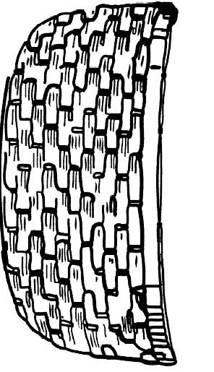
Craft activity - Make a basket of 5 loaves and 2 fish
Colour the basket, fish and loaves. Cut them out and stick them onto a paper plate or piece of card/paper.
OR Print out 2 basket templates and stick/staple them together, leaving the top edge open (like a pocket) to put the loaves and fish in.

